**CRM Application for Jewel Management**

**College Name : KATHIR COLLEGE OF ARTS AND SCIENCE**

**TEAM MEMBERS :**

* Team Leader : DEVAPRAKASH R

Email : deva14538@gmail.com

* Team member : DHARNEESH T S

Email : dharneeshs1305@gmail.com

* Team member : PUGAZHENTHI

Email : shibishinnu2614@gmail.com

* Team member : GURUPRASATH S

Email : guruprasath008808su@gmail.com

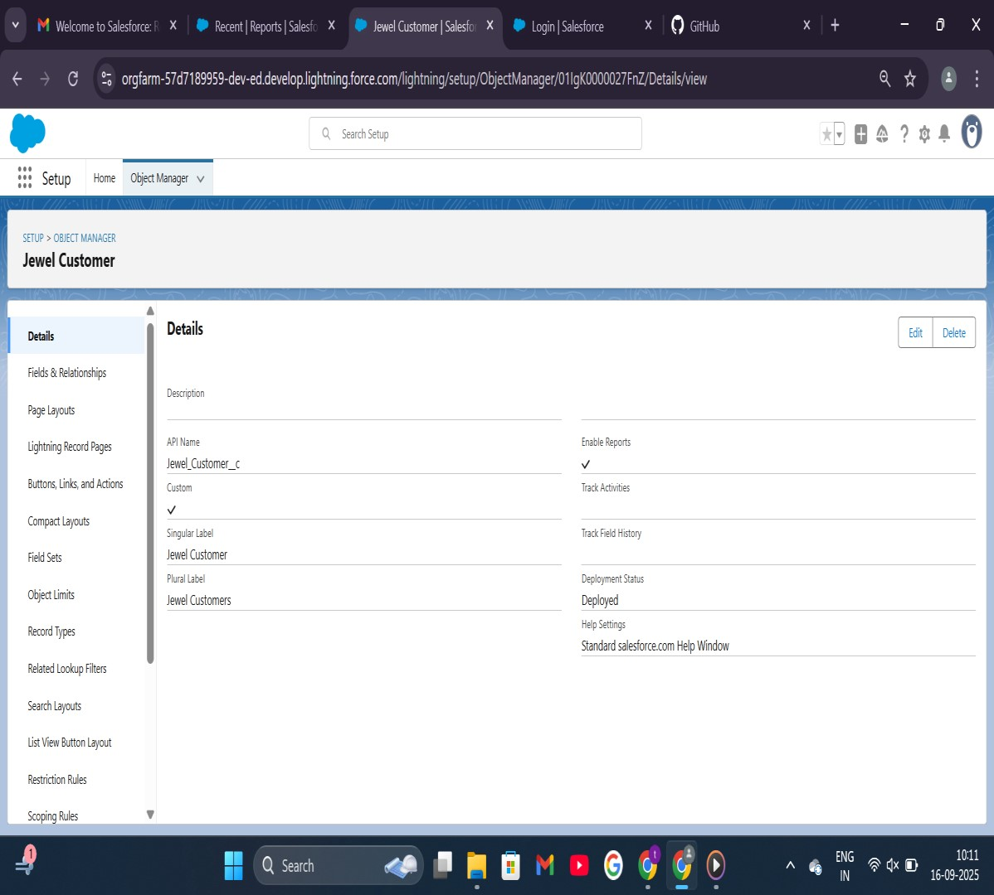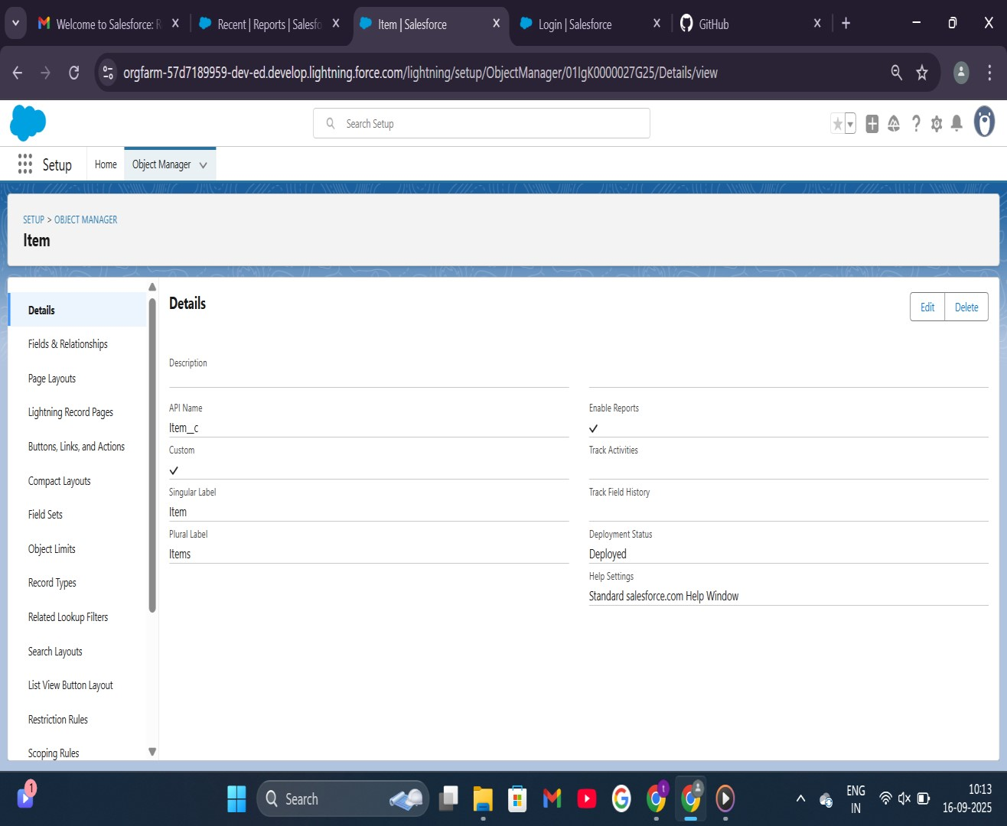**OBJECT**

Jewel Customer Items

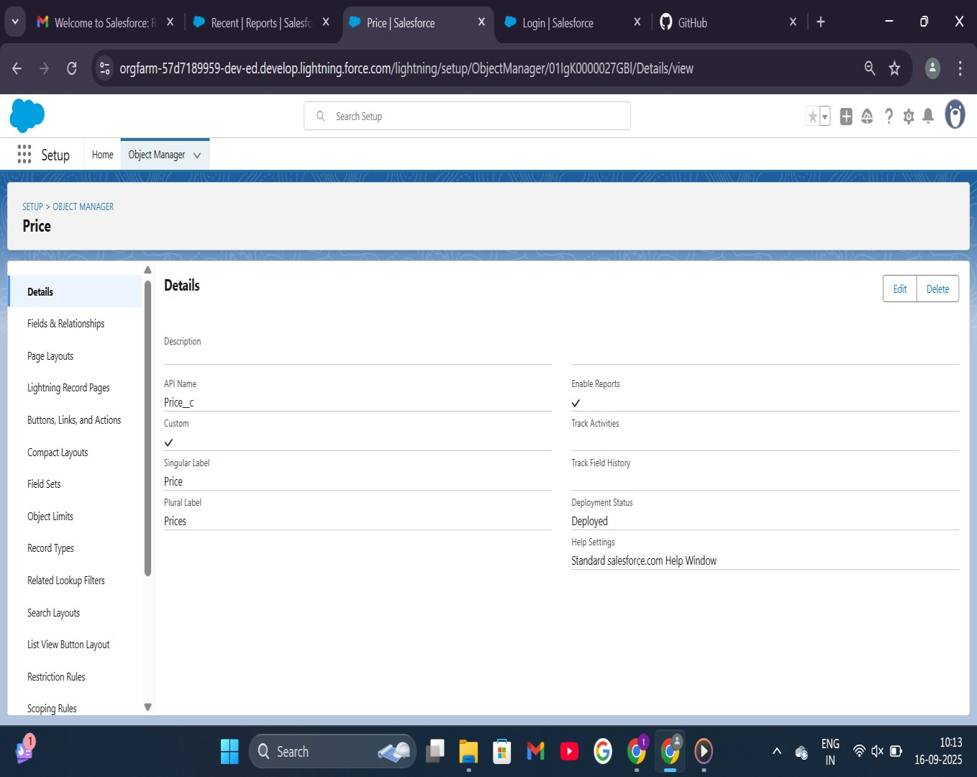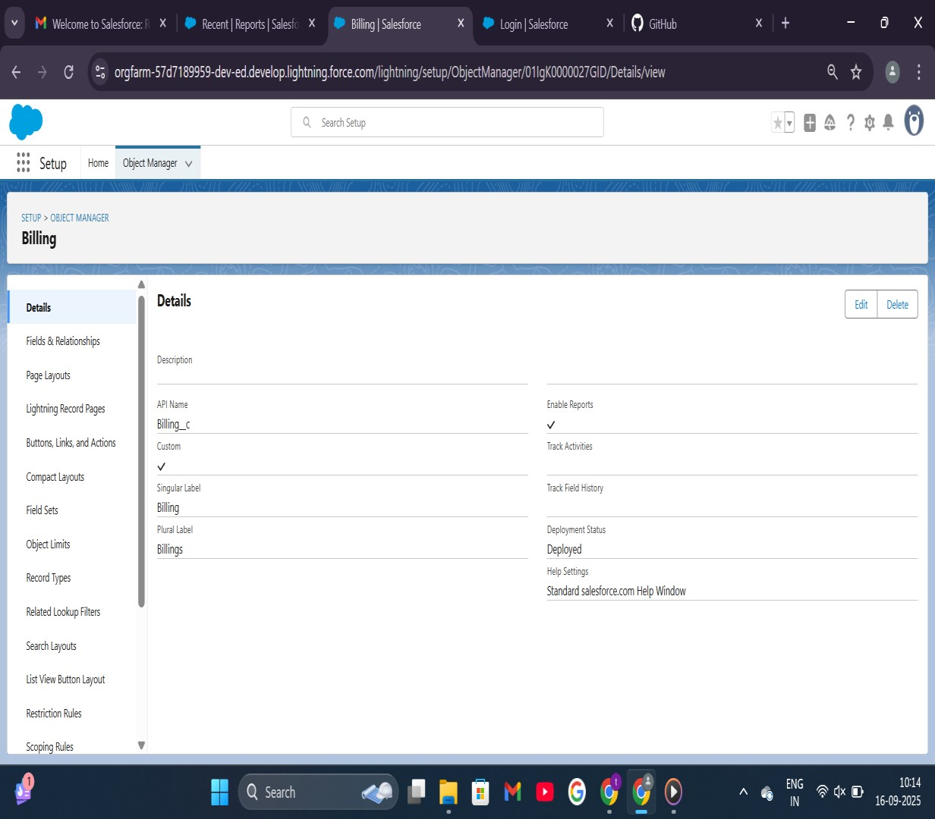 Price Billing

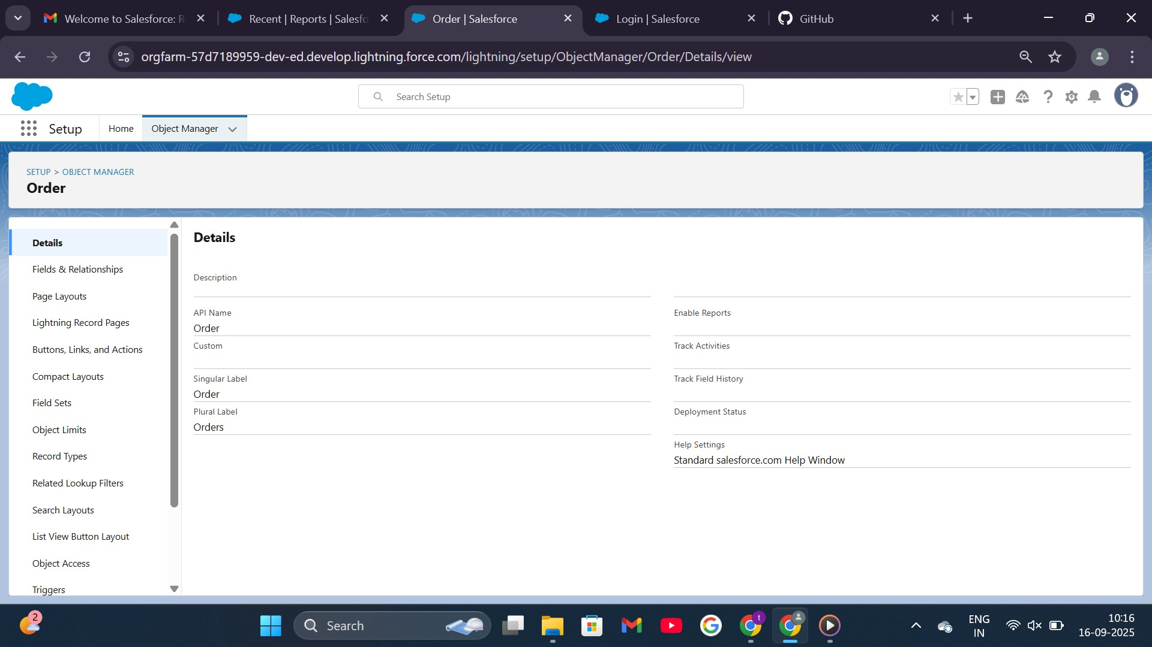Order

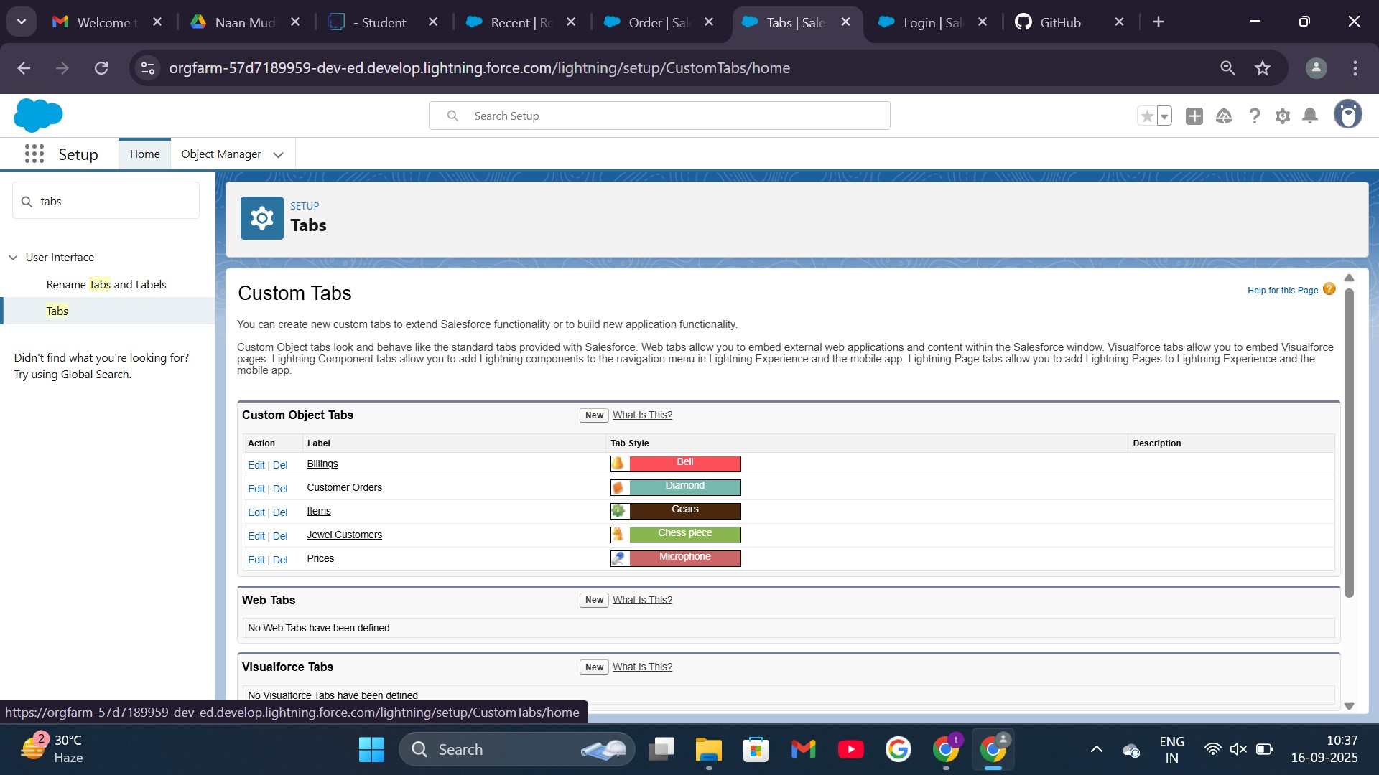**TABS**

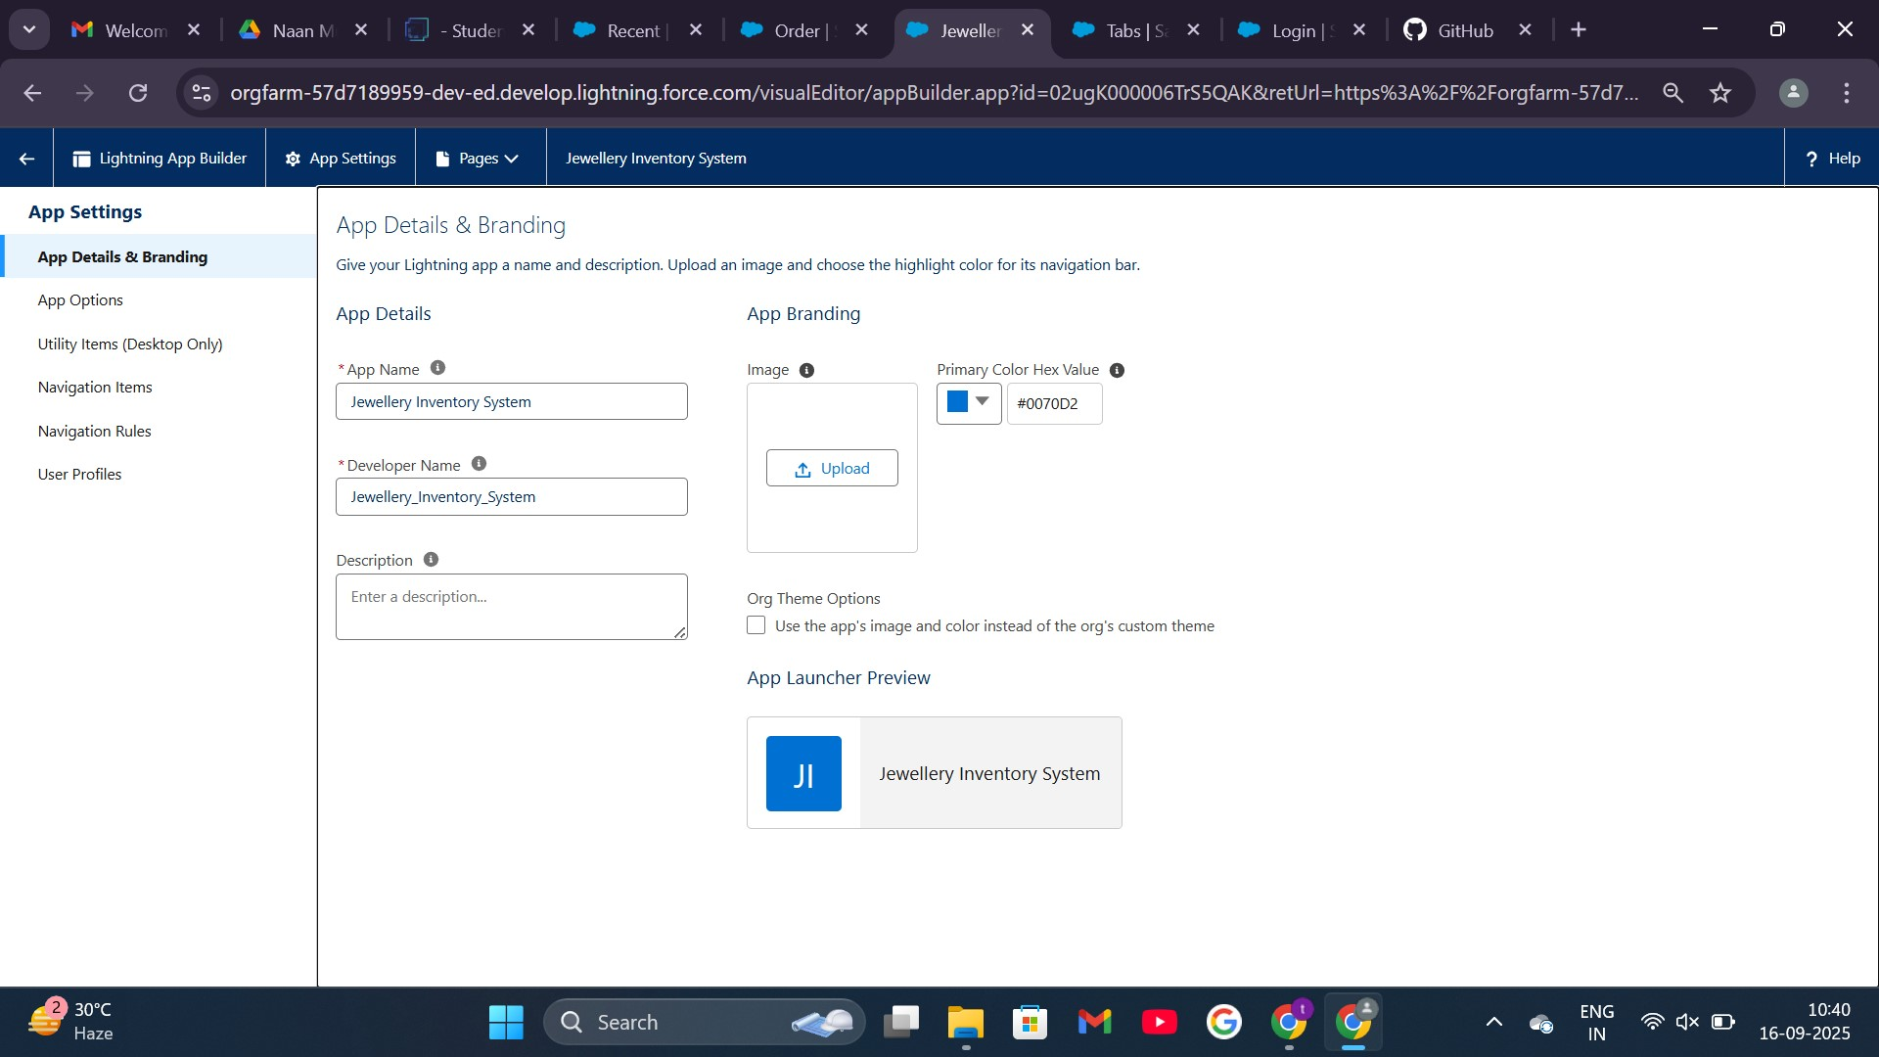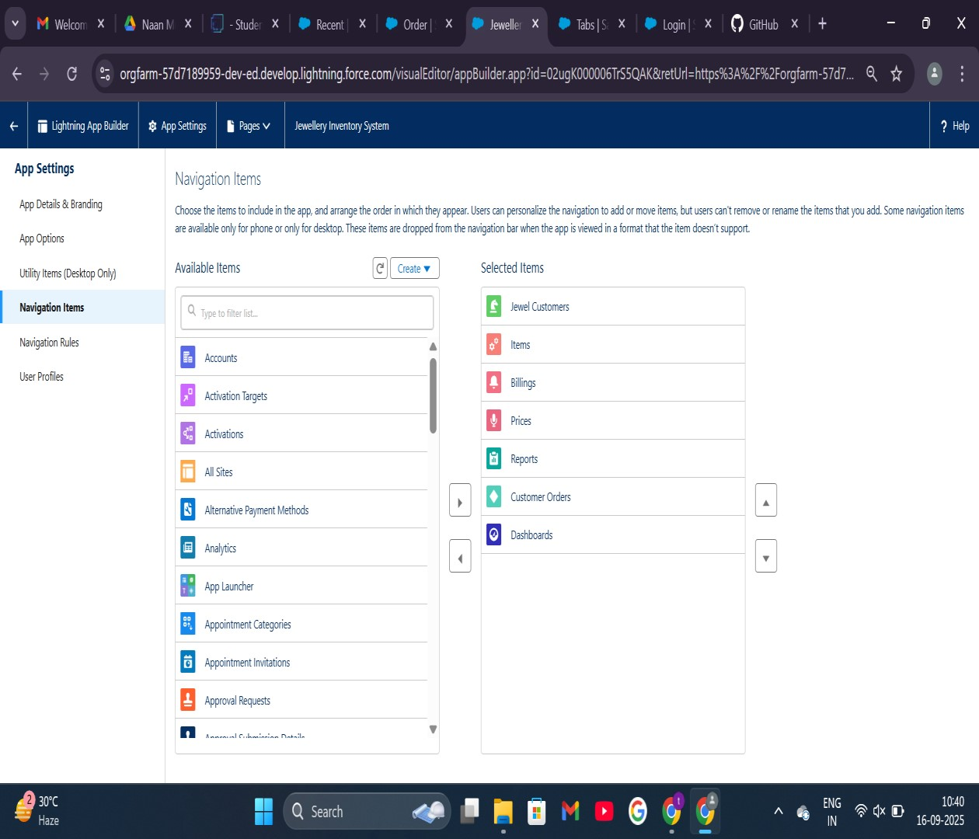

**LIGHTNING APP:**

JEWELLRY INVENTORY APP

# FIELDS

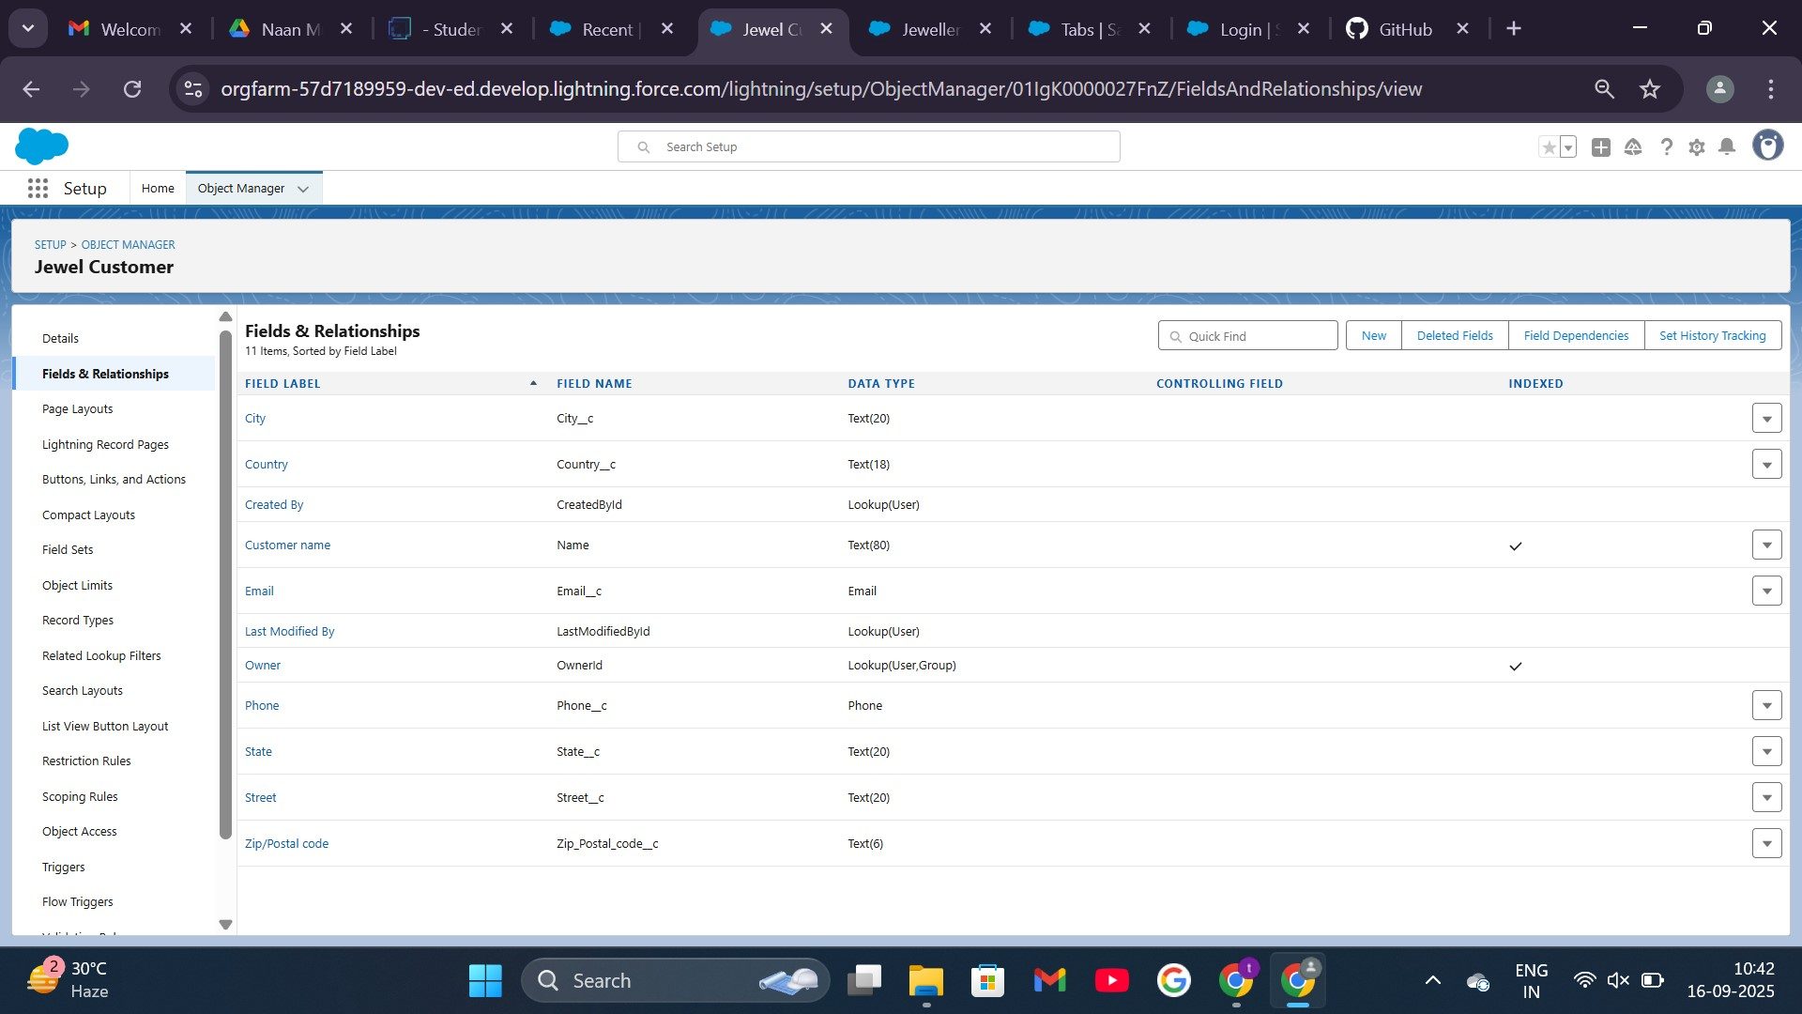**NAMES:** CITY

EMAIL

PHONE

STATE

STREET

ZIP/POSTAL CODE

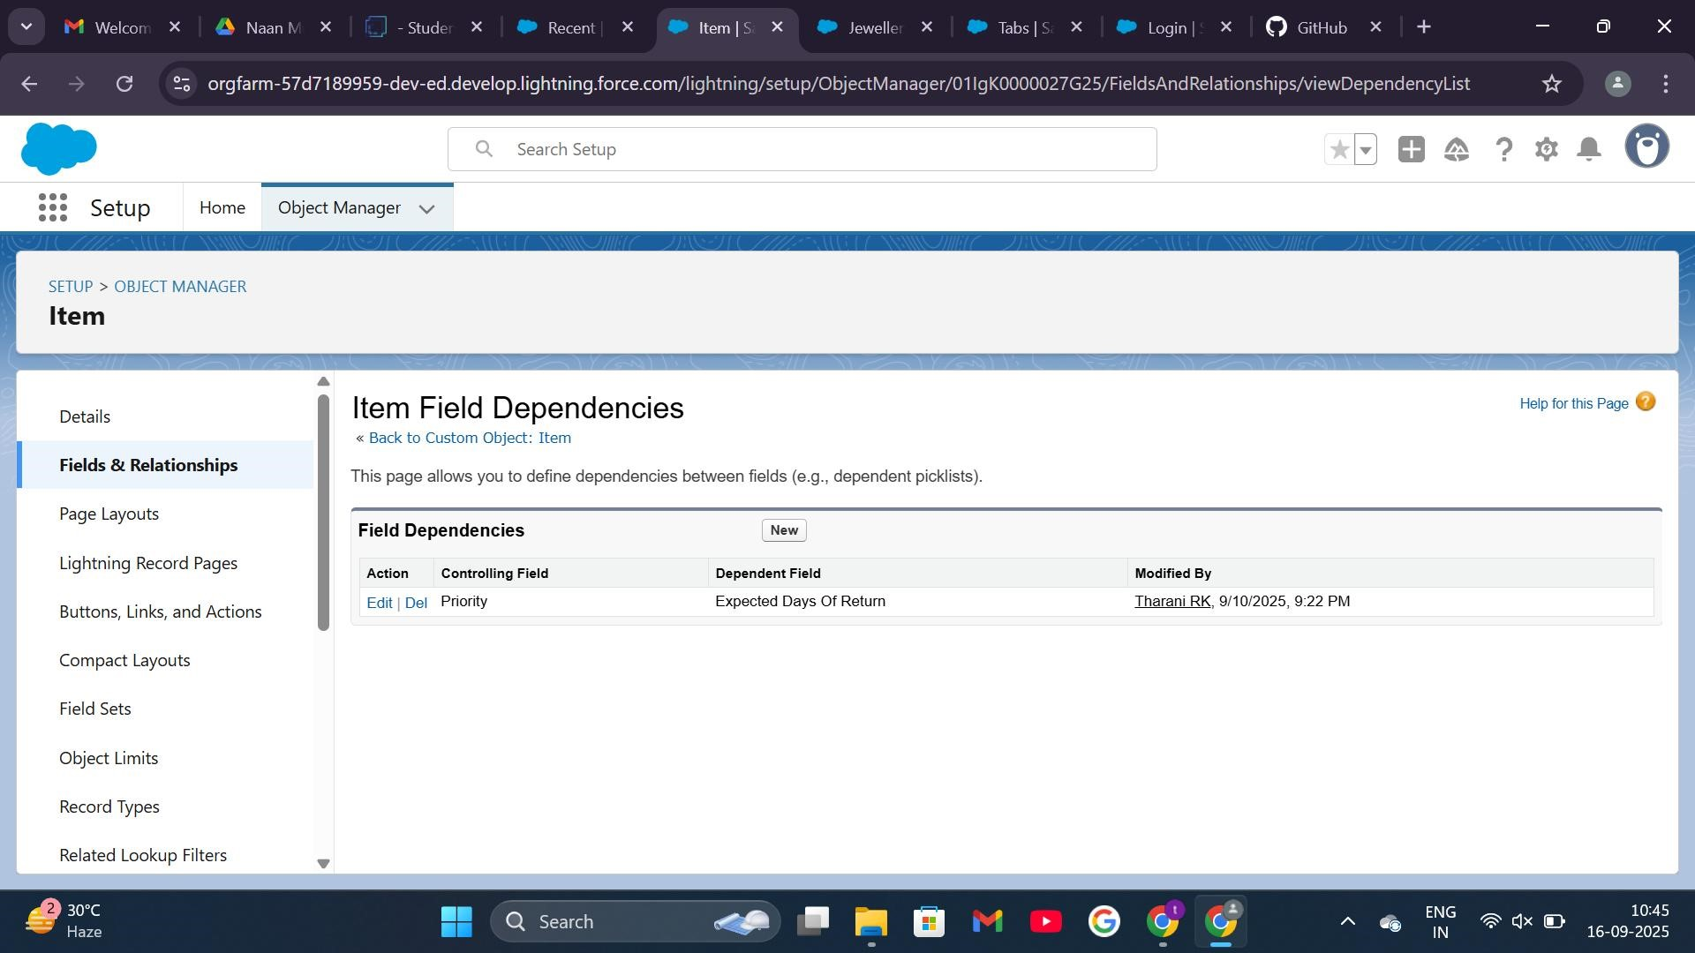**Field Dependencies of items**

## Validation Rules in Jewel Customer

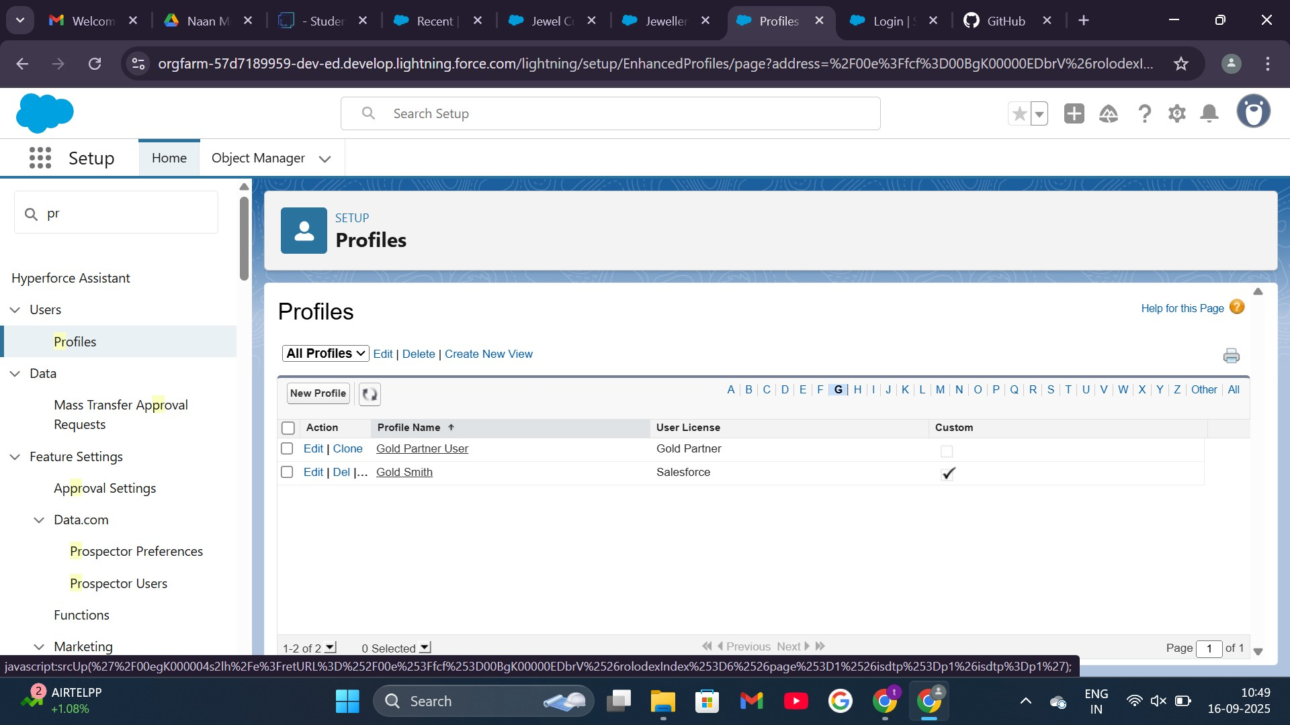**PROFILES**

**Gold Smith**

### ROLES

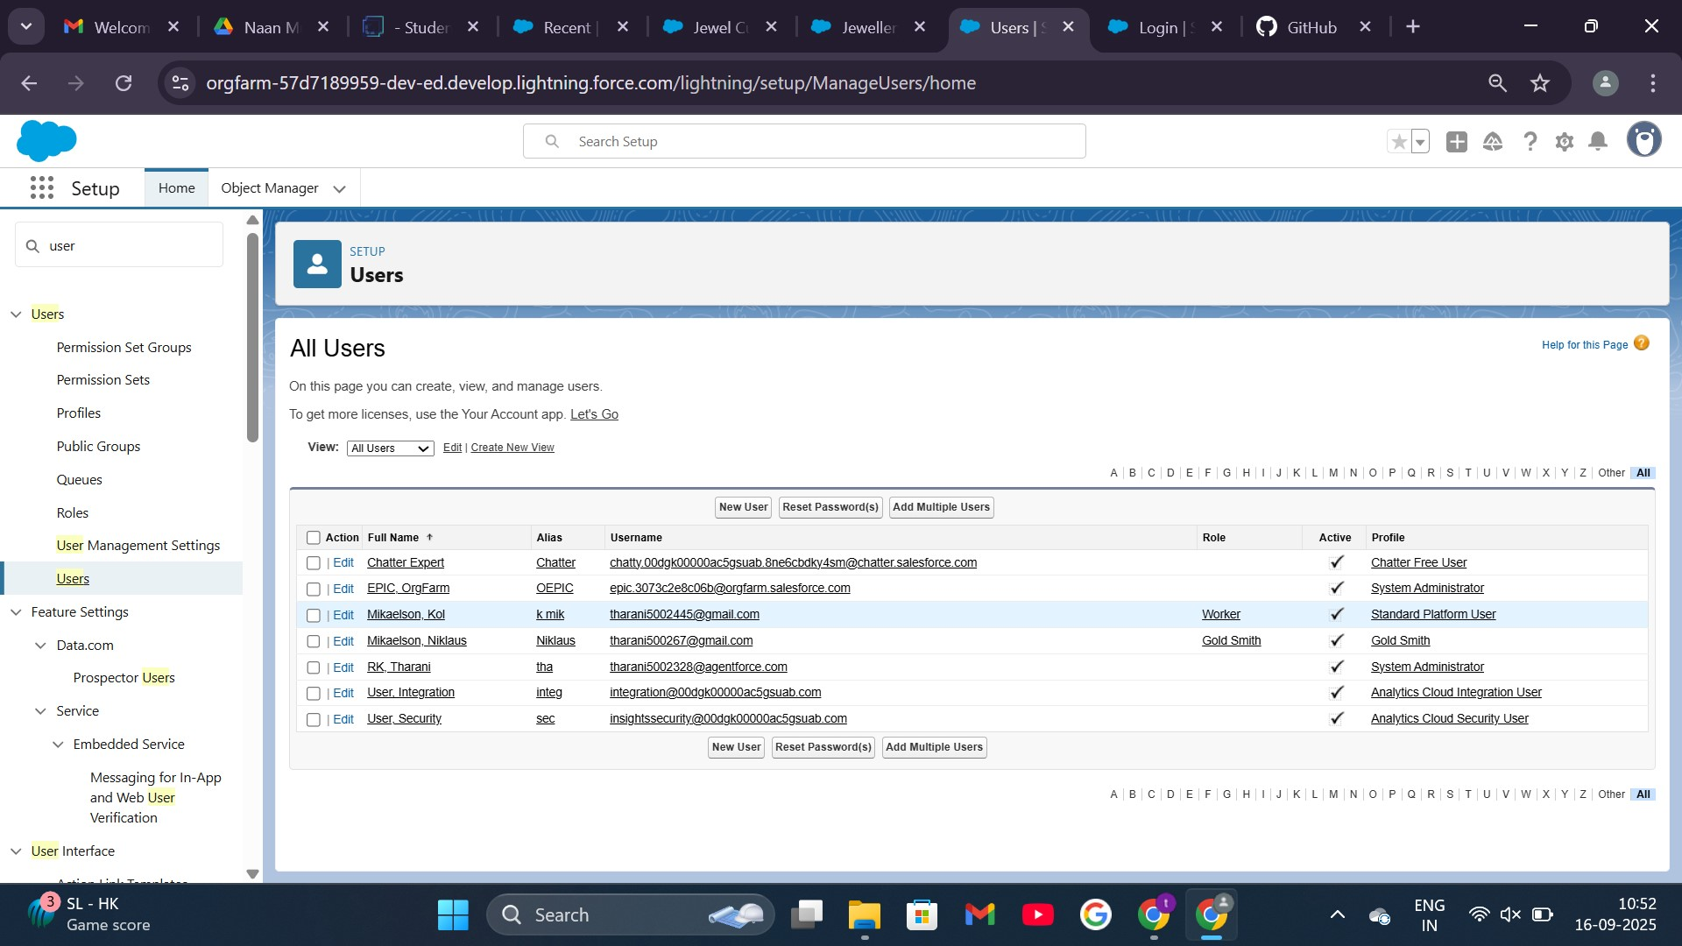**USERS**

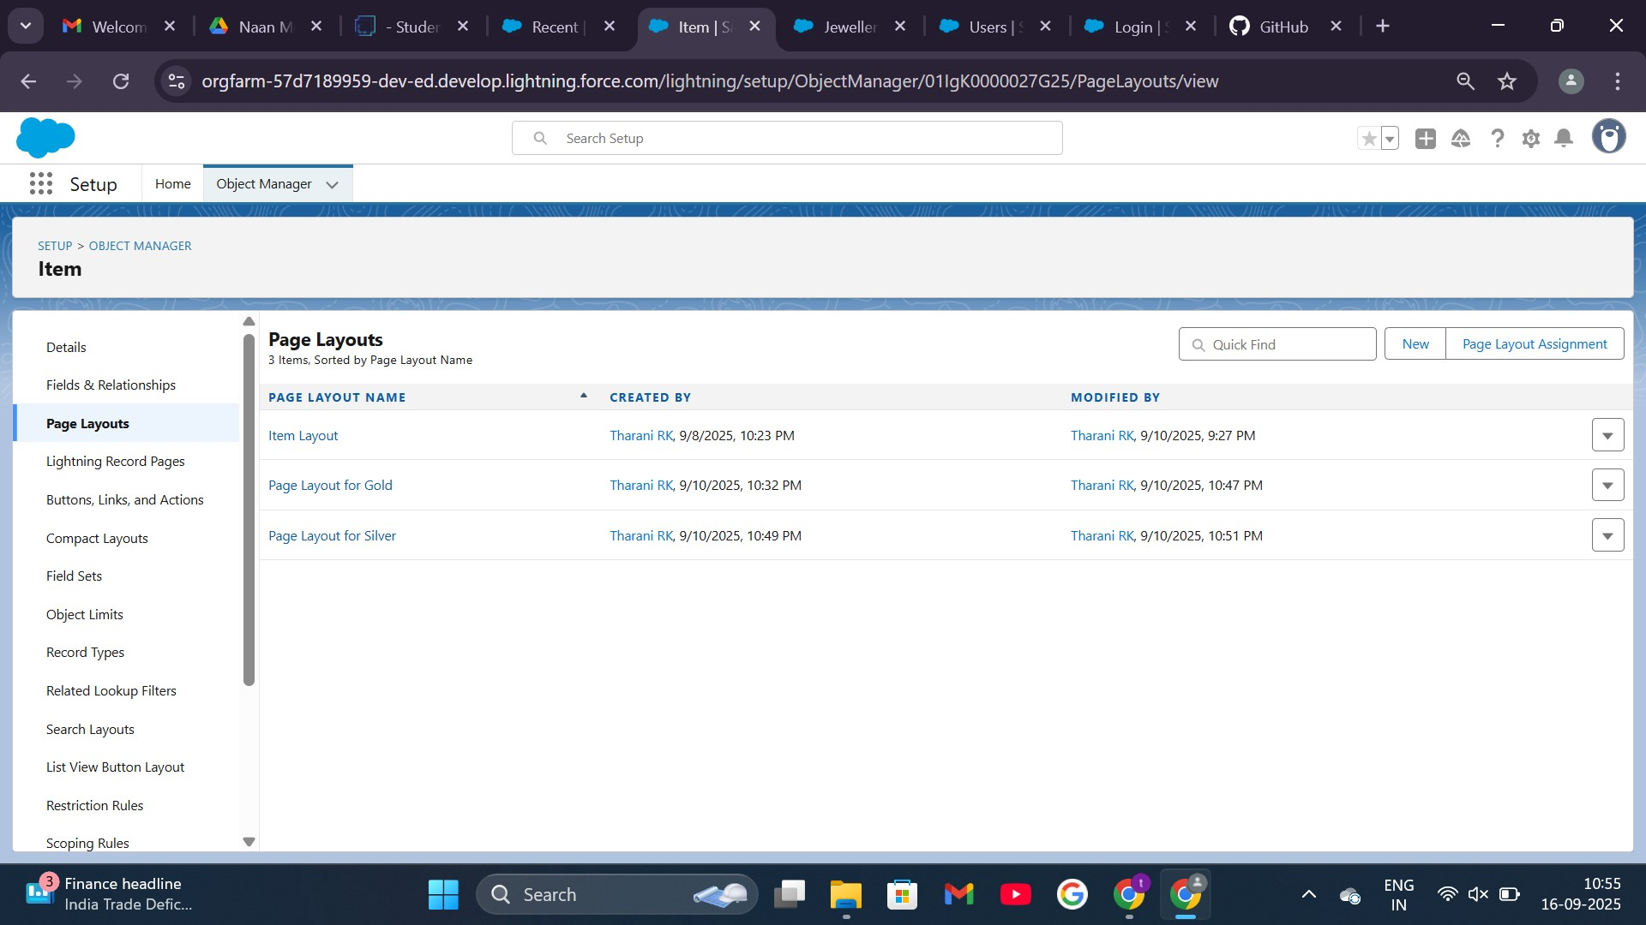**PAGE LAYOUTS**

For Gold and Silver in Item object:

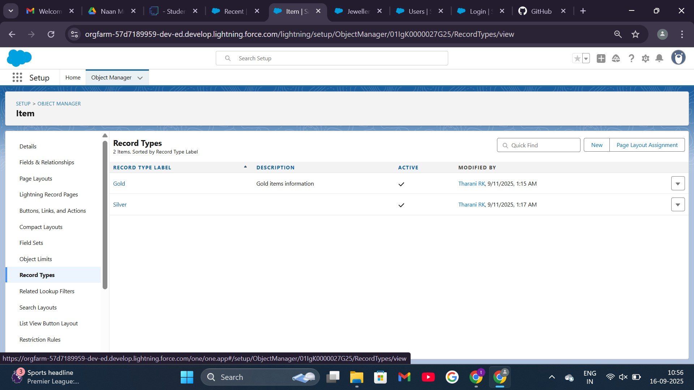**RECORD TYPES**

GOLD AND SILVER:

# PERMISSION SETS

## TRIGGER

**CODE :** public class UpdatePaidAmountTriggerHandler { public static void handleBeforeInsert(List<Billing__c> newBillings) { for (Billing__c billing : newBillings) { billing.Paid_Amount__c = billing.Paying_Amount__c;

}

}

public static void handleBeforeUpdate(Map<Id, Billing__c> oldBillingsMap,

List<Billing__c> updatedBillings) { for (Billing__c billing : updatedBillings) {

Billing__c oldBilling = oldBillingsMap.get(billing.Id);

Decimal oldPaidAmount = oldBilling.Paid_Amount__c;

billing.Paid_Amount__c = oldPaidAmount + billing.Paying_Amount__c;

}

}

}

**Create the trigger:**

**CODE:**

trigger UpdatePaidAmountTrigger on Billing__c (before insert, before update) {

if (Trigger.isInsert) {

UpdatePaidAmountTriggerHandler.handleBeforeInsert(Trig ger.new);

} else if (Trigger.isUpdate) {

UpdatePaidAmountTriggerHandler.handleBeforeUpdate(Tri gger.oldMap, Trigger.new);

}

}

**REPORTS**

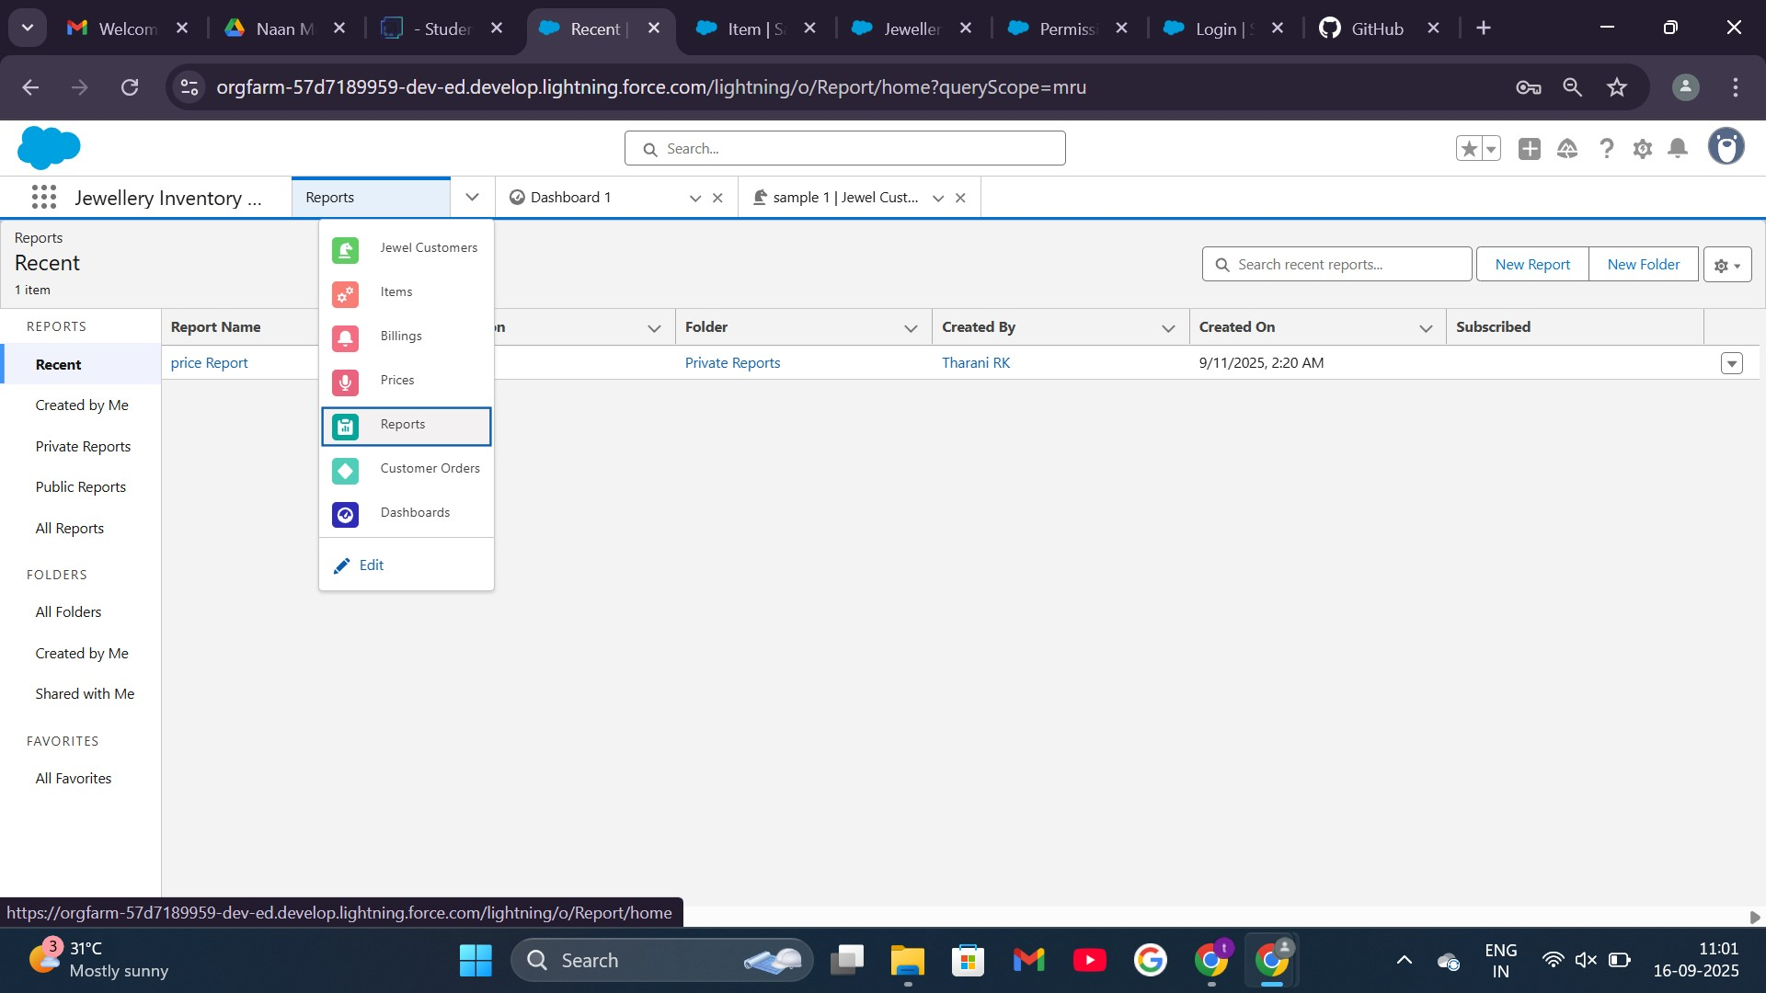JEWELLERY INVENTORY APP REPORTS:

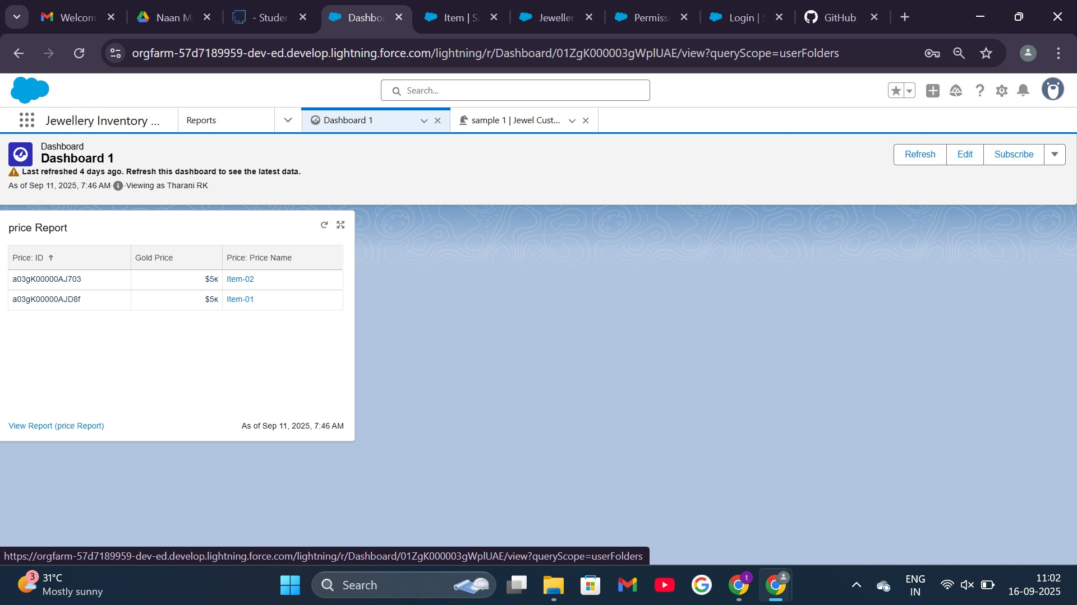**DASHBORD**

# FLOW

BILLING: